SW Engineering CSC648/848 Section 01 Summer 2017

Jizhou Yang- Team Lead- jyang15@mail.sfsu.edu

Rafsan Saadi- CTO

Raghav Parti

Takahiro Odaka

Brandon Yu

Zach Melamed

Team # 3

Stock Photo Marketplace

Milestone 4 v2.0

8/5/2017

Document Revisions

|  |  |  |
| --- | --- | --- |
| Submission Date | Feedback given | Feedback Implemented |
| 8/4/2017 | 8/5/2017 | 8/5/2017 |
|  |  |  |
|  |  |  |
|  |  |  |
|  |  |  |
|  |  |  |

1. Product Summary

Name of Product: Stock Photo Marketplace

The features of Stock Photo Marketplace is listed in the following table.

|  |  |
| --- | --- |
| Feature | Description |
| Browse | Any user can browse our website and see the photos |
| Search | Any user can use the search bar and category filter to search for specific photos |
| Register | Any user can register an account on the website |
| Login | Registered users can login into their account |
| Manage | Registered users can see, edit, upload and delete the photos under his account. |
| Message | Registered users can send and receive messages from other registered users. |

Unique of our product: Message system. Registered users can send and receive message from owner to setup a deal.

The Stock Photo Marketplace can be found by following the link below:

http://sfsuse.com/~su17g03/Home

1. **Usability Test Plan:**

The intended user for this website is anyone who is looking to upload their own media, purchase or view others’ media for recreational or professional use. Since we want to have an ease of use for the website that requires little previous knowledge on how to purchase, view, or upload items online, we have no intended age group, and recommend to get testers from a variety of ages in order to maximize our feedback.

System setup: a laptop with internet capabilities and either Google Chrome or

Mozilla Firefox internet browsers.

Starting point: Website home page

URL of tested system: <http://sfsuse.com/~su17g03/Home>

Task Description:

Below are the following three important tasks in order to successfully test out the search function.

|  |  |
| --- | --- |
| **Task** | **Description** |
| Task | Choose “Background” category |
| Machine State | Default category selected |
| Successful Completion Criteria | “Background” displayed on “Category” tab |
| Benchmark | Completed in 30 seconds |

|  |  |
| --- | --- |
| **Task** | **Description** |
| Task | Find images of cities |
| Machine State | Empty search bar |
| Successful Completion Criteria | “city” typed out in search bar |
| Benchmark | Completed in 30 seconds |

|  |  |
| --- | --- |
| **Task** | **Description** |
| Task | Search for “city” in “Background” category |
| Machine State | Category selected, search query typed in |
| Successful Completion Criteria | Page displaying all images with “city” in the name |
| Benchmark | Completed in 30 seconds |

Completion criteria:

* User has successfully done the following:
  + Found all images in “Background” category
  + Found all images related to “cities”
  + Has gotten a search result based off of the previous choices

**User Satisfaction Questionnaire:**

* The GUI was simple to understand (select one):

__Strongly Disagree

__Disagree

__Neither agree nor disagree

__Agree

__Strongly Agree

* Comments:

_____________________________________________

* It was easy to search for media (select one):

__Strongly Disagree

__Disagree

__Neither agree nor disagree

__Agree

__Strongly Agree

* Comments:

_____________________________________________

* The results displayed were appropriate to the search query (select one):

__Strongly Disagree

__Disagree

__Neither agree nor disagree

__Agree

__Strongly Agree

* Comments:

_____________________________________________

1. Quality Assurance Test Plan

|  |  |  |  |  |
| --- | --- | --- | --- | --- |
| **User Type** | **Test Setup and Description** | **Test Input** | **Expected Result** | **Test Status** |
| **Non-registered User** | ***Setup:***  Open the following link in the browser: <http://sfsuse.com/~su17g03/Home>  ***Description:***  Users shall be able to search for photos by using a keyword or category. | ***Category*:** View  ***Search Box:*** beach  ***Click Button:*** Search | "Search result returned with one photo of a beach" | Pass |
|  | ***Setup:***  Open the following link in the browser: <http://sfsuse.com/~su17g03/Home>  ***Description:***  Users shall be able to browse photos. | ***Category*:** “empty”  ***Search Box:*** ​“ empty”  ***Click Button:*** Search | "Search result will return with 30 images from the system" | Pass |
|  | ***Setup:***  Open the following link in the browser: <http://sfsuse.com/~su17g03/users/add>  ***Description:***  Users of the website shall be eligible to become Registered Users of the website. | ***Form Fields:***  Email  Password  Confirm Password  ***Click Button:*** Submit | Successfully bring up registration page and register as a user. | Pass |
| **Registered User (Buyer)** | ***Setup:***  Open the following link in the browser: <http://sfsuse.com/~su17g03/users/login>  ***Description:***  Users shall be able to contact the seller. | ***Login:*** with email and password  ***Click Button:***  Contact Seller (of the interested product) | "Successfully bring up message composition page and be allowed to contact the seller" | Pass |
|  | ***Setup:***  Open the following link in the browser: <http://sfsuse.com/~su17g03/users/login>  ***Description:***  Users shall be able to purchase photo | ***Login:*** with email and password  ***Click Button:***  Download (of the interested product) | Successfully bring up download page with downloadable link | Pass |
| **Registered User (Seller)** | ***Setup:***  Open the following link in the browser: <http://sfsuse.com/~su17g03/users/login>  Login with username and Password  Navigate to “MyProfile” or directly access the following link: <http://sfsuse.com/~su17g03/profile>  ***Description:***  Contributors shall be able to upload photos to the website. | ***Click Button:*** “Manage Media”  ***Click Button:*** “Upload Media”  ***Form***: Fill it up  ***Click Button:*** “Save Media” | Successfully save media and that can be seen in the “Media Library” list | Pass |
|  | ***Setup:***  Open the following link in the browser: <http://sfsuse.com/~su17g03/users/login>  Login with username and Password  Navigate to “Manage my media from ”“MyProfile” or directly access through following link: <http://sfsuse.com/~su17g03/Uploads>  ***Description:***  Contributors shall be able to manage (view, edit, delete) their uploaded photos to the website. | ***Click Button:*** “Upload Media”  ***Form***: Fill it up  ***Click Button:*** “Save Media”  ***To view detail:*** *Click on the media “Title”*  ***To edit/delete media:*** *Click on the appropriate action link(Edit/Delete) from the “Media Library” list* | Click on “Title” successfully show the media details.  Click on the “Edit” action allow user to edit/update the media info  Click on the “Delete” action allow user to delete media | Pass |
|  | ***Setup:***  Login with username and Password  Navigate to “Message list” from  “MyProfile” or directly access through following link: <http://sfsuse.com/~su17g03/Communications/msgList>  ***Description:***  Contributors shall be able to see/ read messages from his media buyers. | ***Click Link:*** “View Message” | Direct link shows all messages  Click on “View Message” action shows details of a message | Pass |

4) Code Review

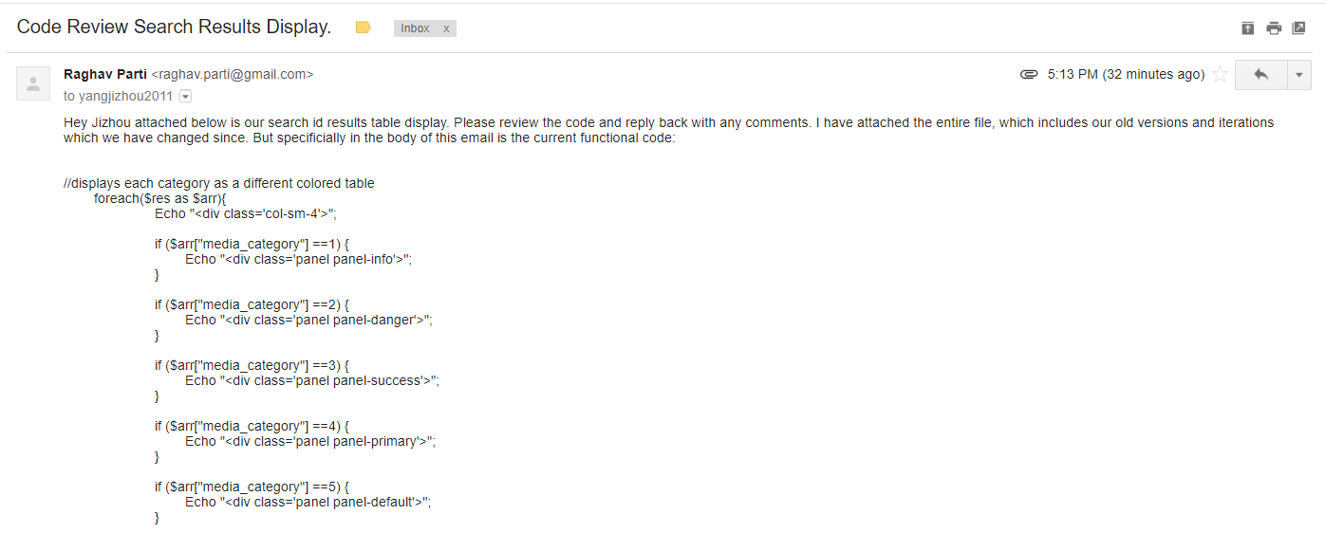

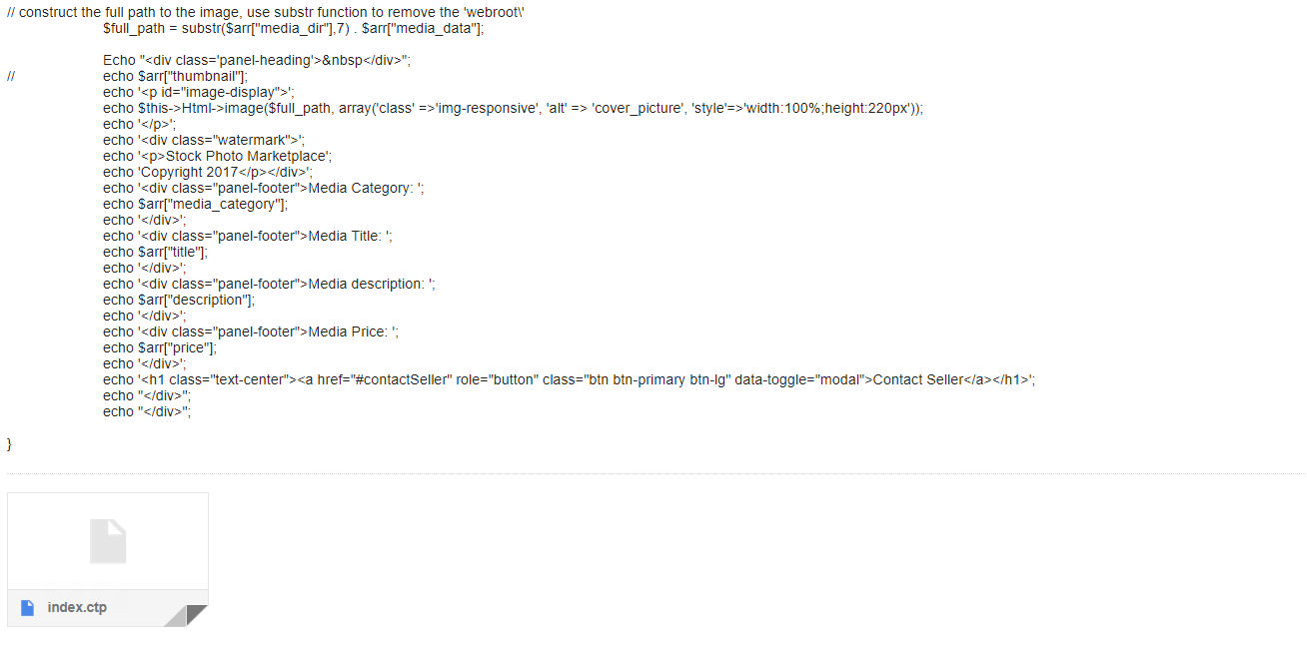

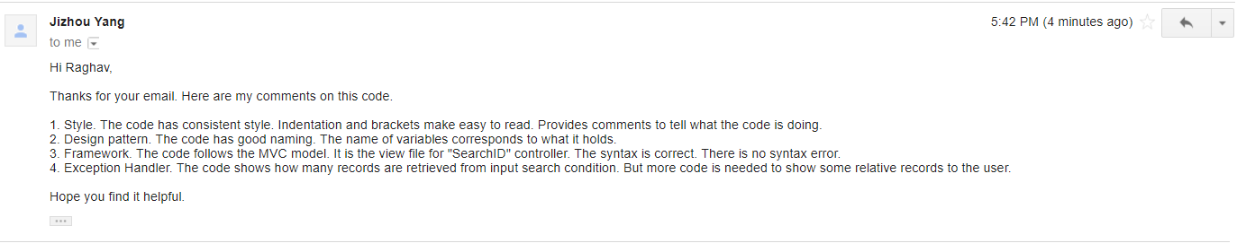

5) Self check on best practices for security

* Major assets we are protecting:
  + Images uploaded by contributors
    - As this is a stock photo marketplace, the raw image itself is the important asset and thus should be and is protected from being accessed and downloaded by a guest
  + User information
    - In order to message a contributor, a person must first register as a user. This registration requires email and password. Both are important assets to be protected
* Password protection
  + Login and register passwords are encrypted passwords that can’t be seen or accessed by anyone whether they be guest, registered user, contributor, or administrator
* Input form validation
  + Search bar input validation- max 30 characters
  + Search bar input validation- no special characters (alphanumeric only)
  + Search bar input validation- no empty searches
  + Search result output validation- provided valid search, provide some result
  + Empty search bar will display all results
  + SQL Form injection prevention

6) Adherence to original non-functional specs

1. Application shall be developed using class provided LAMP stack- DONE
2. Application shall be developed using pre-approved set of SW development and collaborative tools provided in the class. Any other tools or frameworks must be explicitly approved by Anthony Souza on a case by case basis.- DONE
3. Application shall be hosted and deployed on Amazon Web Services as specified in the class- DONE
4. Application shall be optimized for standard desktop/laptop browsers, and must render correctly on the two latest versions of all major browsers: Mozilla, Safari, Chrome. -DONE
5. Application shall have responsive UI code so it can be adequately rendered on mobile devices but no mobile native app is to be developed -DONE
6. Data shall be stored in the MySQL database on the class server in the team's account -DONE
7. Application shall be deployed from the team's account on AWS -DONE
8. No more than 50 concurrent users shall be accessing the application at any time -DONE
9. Privacy of users shall be protected and all privacy policies will be appropriately communicated to the users. -DONE
10. The language used shall be English. -DONE
11. Application shall be very easy to use and intuitive. No prior training shall be required to use the website. -DONE
12. Google analytics shall be added -DONE
13. Messaging between users shall be done only by class approved methods and not via e-mail clients in order to avoid issues of security with e-mail services. -DONE
14. Pay functionality (how to pay for goods and services) shall not be implemented. -DONE
15. Site security: basic best practices shall be applied (as covered in the class) -DONE
16. Modern SE processes and practices shall be used as specified in the class, including collaborative and continuous SW development -DONE
17. The website shall prominently display the following text on all pages *"SFSU Software Engineering Project, Spring 2017. For Demonstration Only"*. (Important so as to not confuse this with a real application). -DONE